Name ______________________________ HOMEWORK Oct. 17-21
Put your initials by each night that your child practiced the following:
____Monday ____Tuesday ____Thursday
*Nightly Homework*
1. Practice saying letter names and sounds.
2. Count numbers 1-25.
3. Practice assigned Sight Word list in red reading folder.
Name the letters and sounds.
Mm Tt Ss Bb Aa Nn
Dd CC PP Ii

Monday: Draw a picture of a word that starts with:
Short i Long i
Circle the correct beginning sound for each word:
b n c p c n c n b n d p
TUESDAY- Practice writing your first and last name two times. Only capitalize the beginning.

_____________________________________________________________

THURSDAY- Color the pictures if they rhyme.

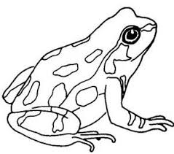

Sid Bit It!
By Sarah Roman
Illustrated by Steve Dorado
Sid and Dad sit. Dad has an

apple . Sid has a peach .
Sid bit it. Sid bit the pit!
“Dad! Dad, my tooth !”
Dad and Sid go to Min.
Min is a dentist .
“Sid bit it, Min! Sid bit the pit.”
“Sit, Sid. Min can pat it.
Min can pat the tooth .”
Min did it! Sid smiles .
Read these words.
the and go
is can to

